

Newsletter: Autumn 2019

Message from the Chair
Welcome to our autumn newsletter of 2019. We have achieved a great deal since our last edition more details of which you can find in this newsletter. We also welcome our new Board Manager, Ash Manzoor, whom you can read more about on page two along with other news around staff changes.
Well, I hope you enjoyed your summer and you had a break and got a chance to relax. I did enjoy a break but have also been making new connections and working links with colleagues across the city. More news about the new partnerships is featured later.
A special mention must go to the award-winning Birmingham Freedom Project who have had a busy summer winning awards for their exceptional work to support women and children who have suffered domestic abuse. Well done Freedom Project I am pleased and proud that you are an active partner of our Board!
In other news, work on our new website is taking place in earnest – so I hope that not only will you find invaluable information in newsletters and other events and publications we circulate that you will also be able to use the new website, due later in the Autumn, for a source of information for professionals and public.
I hope you will also appreciate there is a wealth of information included in this newsletter, I am keen that we continue to learn from each other in all of the various elements of safeguarding. I remain committed to sharing knowledge and your best practice with all partners to ensure we are all prepared and ready to continue our role of safeguarding adults.
As ever I am grateful of the work that you do to safeguard adults in Birmingham and remain passionate about continuing this work together as partners.
Cherry Dale, Independent Chair, BSAB

Changes to the BSAB team
Goodbyes and Welcomes
Pauline Mugridge, our Chair of the Scrutiny and Governance Committee and Birmingham City Council Assistant Director, is moving onto a different role within the Council in September. I would like to thank Pauline for all of the support that she has given to the Birmingham Safeguarding Adults Board over the last 18 months. I have been very grateful for her commitment to making sure we are able to achieve our ambitions and priorities and for helping us get over a good few stumbling blocks.
We wish you good health and happiness for the future Pauline.
I am very happy to say that The Birmingham Safeguarding Adults Board will now sit in the directorate of Maria Gavin, Assistant Director Quality and Improvement, and I would like to welcome Maria fully to the Board and to the role of Chair of the Scrutiny and Governance Committee. We are all very much looking forward to working with you Maria.
Another huge thank you goes to June Marshall who has been supporting us one day a week since last year with our Communications and Engagement work and has worked hard to professionalise our communications and get our website delivery back on track. June we are ever grateful for all of the hard work you have put into BSAB and all that you have achieved for us in such a short space of time.
I would also like to formally welcome Ash Manzoor to his new role as our Board Business Manager, Ash comes with a wealth of experience and knowledge of leading work on Safeguarding Adults Boards and I am sure he will be very keen to meet and work with you all over the coming months. I am sure you will be a great success in Birmingham Ash, and I look forward to you taking us from strength to strength.
And a message from Ash
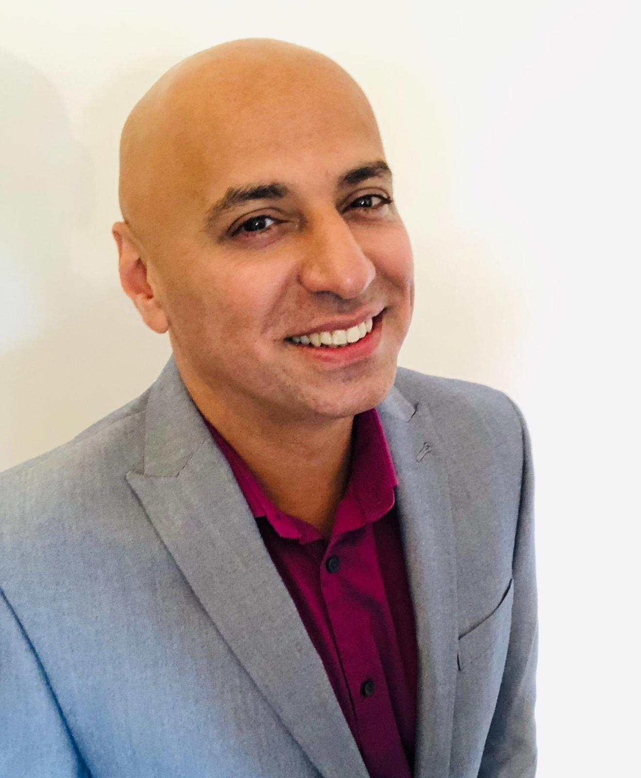
Ash Manzoor has joined us as Business Manager for the Birmingham Safeguarding Adults Board following 27 years working in a variety of operational and strategic health and social care roles at Kirklees Council in West Yorkshire with his most recent post being Safeguarding Adults Board Manager. Ash has also recently worked with the Safeguarding team at NHS Digital and has contributed to regional and national work in the Adult Safeguarding field.
When not working, Ash likes to lead a busy and active life both socially and going to the gym to burn off the calories from his baking and love of food.
Ash says he is looking forward to his eventual move from his home in Yorkshire to the Midlands, as well as supporting and working with the Safeguarding Adults Board to achieve our aims and objectives. Ash can be contacted at: Asif.Manzoor@birmingham.gov.uk and will be supported by the support BSAB support team.
And the new appointments don’t stop there. The BSAB team is now permanently ably supported by Dawn Foster-Denham who comes with a wealth of knowledge and administrative experience to support the Administration of the Board. Welcome to both of our new team members!

Who needs the Oscars?
On 11th July, the team from the Freedom Project attended the West Midlands Police & Crime Commissioner awards ceremony at Birmingham City Football Ground. There were four main awards up for grabs: Outstanding Citizen, Outstanding Young Citizen, Outstanding Community Project and Outstanding Young Community Project.
The Freedom Project team, led by Jacky Mulveen, Project Manager deliver a range of awareness and empowerment programmes for women affected by domestic abuse in Birmingham.
All programmes are women only and are delivered by two female facilitators both of whom have many years’ experience in supporting women affected by domestic abuse.
Nominations for the award are taken from the community and provide an opportunity to celebrate the untold stories of those who volunteer, campaign or take part in acts of extraordinary bravery and the Freedom project were successful in being the runner up in the Outstanding Community Project Award.

The team were delighted to have been nominated and recognised for the services we provide in empowering women and consequently their children, to heal from the impact of domestic abuse. It is vital that we as a City understand the impact of trauma on the lives of families and have the right services in place for them to heal and thrive.
It was a lovely evening and we couldn’t help noticing that the wonderful display of balloons would look lovely at our women’s celebration event which was taking place the next day!

And it didn’t stop there… on 7th August we received the Chief Constable’s Community Service Award from Dave Thompson. Nominated by Police Community Support Officer, Mohini Parmar from Brandwood Team as a recognition of our longstanding work in delivering awareness, empowerment and parenting programmes for women who have experienced domestic abuse.
Our programmes are in constant demand with 70+ women accessing our programmes on a weekly basis. Dave Thompson, West Midlands Police Chief Constable said. ‘You put your heart and soul into this project and have countless numbers of success stories where you have changed people’s lives for the better.’
On both occasions it was lovely to be amongst so many wonderful individuals and organisations doing so much amazing work and hearing their stories of bravery, courage, strength and compassion.
To find out more about our work – please visit www.birminghamfreedomproject.org or call us on 07868163103.

An Introduction to Birmingham Poverty Truth Commission
What is Birmingham Poverty Truth Commission?
“A group of people who have some experience of various kinds of poverty, in a room with people who have some position of influence in a community and in a space where there’s kind of no hierarchy and everyone’s allowed to be human together and share experience and work on how we make things better together. That’s how I tend to describe it” Testifying Commissioner

An Upside-Down Commission
The idea of a commission is not new. Where a problem or issue is identified, people, usually professionals in the field, are tasked with exploring it and then making a set of recommendations. A good commission would involve some sort of consultation with the people affected by the issue, but consultation is usually as far as it goes.
A Poverty Truth Commission turns this model on its head and starts with the people who really know what the sharp end of poverty looks like because they live it.
The aim is not a set of recommendations but a set of relationships, in the hope that those relationships would encourage and enable those with influence to operate differently in their sphere.
So Birmingham Poverty Truth Commission started, by bringing together a group of people who have lived experience of poverty in Birmingham and were willing to share their stories in the knowledge that their experiences reflected the lives of others living in the city.
The group met over several months sharing stories, building trust, forming friendships, identifying commonalities and through facilitated conversation discussing what they would like to say to people of influence, those with power and authority, so that they could better understand life from their perspectives.
In October 2017 that group, known as the Testifying Commissioners, invited people of influence in the city from the business, public, faith and third sector, together with friends and family to come to a launch event and hear some of their experiences, told in their own words and in a variety of different ways.
“Experiences of poverty, its causes, roots, impacts on people’s lives are complicated.
The thing is though, no single label can fit someone’s experience. There’s no such thing as a single-issue life. No human being fits neatly into a box, however hard we try, or how much easier it would be for the system. However, many words we try and use, they’re just pieces of a jigsaw too complicated to boil down into a single image or statement. The experiences shared here are just single pieces of that jigsaw. But everything you see and hear is true” Birmingham Poverty Truth Launch

At the end of the launch event influential people from business, university, media, housing, police, education and third sector accepted an invitation to join as City Leader Commissioners with the Testifying Commissioners to form the full Birmingham Poverty Truth Commission.
Throughout 2018 the Commission met every two weeks to share personal story, hear different perspectives and explore more deeply the themes that emerged. Three key themes were:
- Child Poverty and Education
- Housing and Homelessness
- Mental Health and Wellbeing

During the Commission we hosted four Conversation Events on our themes to which a small number of key senior strategic leaders were invited to come, listen and share in the conversation.
“One of the really important things about Poverty Truth is that there’s no hierarchy. It doesn’t matter what your job is or how important you are, or what your life experience is, when you’re in this room you’re all equal, and the intention is we influence each other by understanding each other’s stories” Poverty Truth Facilitator
Our conversations have been uniquely human – funny, poignant, vulnerable and honest – where both joy and pain have been shared in an atmosphere of mutual acceptance and respect.
“I felt really moved by all the testimonies and the sharing and I wanted to tip my hat to everybody for sharing because it’s the strength of coming to these sessions and its really very moving and thank you for it” City Leader Commissioner .
So as the Commission ended its formal period of activity and regular meetings it has brought a challenge to Birmingham rather than the typical list of recommendations that result from consultation. We were challenged by a comment from a City Leader Commissioner.
“I used to be a proud Brummie until I started this. How can we be proud when we are letting so many of our citizens down”?
This led to us seeking a more holistic challenge to all in the city by asking and inviting anyone interested to join us in asking and answering the key questions
- How do we lift the labels we put on people to see, hear and understand the human being?
- How do we build relationships in a non-confrontational way to hear and understand the truth of what’s going on?
- How can we use our influence, wherever we are, to make things better?
- In doing so, can we rehumanise our broken systems?

It has been encouraging to see how other people outside of the Commission who have read the report have found a connection with the ethos and approach that the Commission has adopted and responded to our call to find a different sort of approach to the key issues that Birmingham faces.
One such person is Cherry Dale who has sought a conversation about how Birmingham Safeguarding Board might learn and collaborate with Birmingham Poverty Truth Commissioners. We were delighted and encouraged that Cherry saw an opportunity to explore how our challenges might be applied to Birmingham Safeguarding Adults Board (BSAB) overarching ambitions to build imaginative partnerships that help to:
1. Make safeguarding everyone’s business; ensuring everyone understands what it is and what to do.
2. Make Safeguarding Personal (MSP) - we champion person-centred approaches. Our ambition for MSP includes all relationships people have inside and outside of their family or care setting known as contextual safeguarding.
3. Risk Enablement - supporting people to maintain as much control and choice over their own lives as possible.
More specifically we found an area of mutual concern in our desire to address the issue of ‘exempt accommodation’ which many of our Testifying Commissioners had direct experience of and which became one of our priority areas for investigation.
For those of us involved in Birmingham Poverty Truth Commission it is very exciting that Cherry has enabled us to see possibilities for the follow up work of the Commission and it is particularly encouraging that Cherry, as a representative of BSAB, is keen to join a collaboration of influential partners in the city who are keen to wrestle with the challenges we have raised and to explore how the learning from the Commission might shape future policy and practice in Birmingham. We look forward to working together.
Should you wish to learn more about Birmingham Poverty Truth Commission and to read our report ‘A Window on Our Conversations’ please contact Esther Spence at Esther@brumpovertytruth.org

Birmingham Safeguarding Adults Board (BSAB) Update
The last meeting took place on 18th June. Items discussed included; the Panorama Programme which featured the abuse being undertaken at the unit owned and ran by the Cygnet Group. Its impact has far reaching consequences as the NHS group overseeing this home was aware of the treatment and complaints yet failed to share details with other partner organisations including those in Birmingham who have placed citizens in the home. Birmingham and Solihull Clinical Commissioning group and Birmingham City Council gave full assurances at the meeting that our own Transforming Care placements are all regularly quality assured and the people living there are fully consulted on how it feels for them. The Care Quality Commission are being invited to attend the next meeting to discuss the incident and to review what lessons can be learned.

The Board also viewed a short film by West Midlands Ambulance Service which David Gray, BCC Adults safeguarding lead has used to share details of risk enablement with colleagues across the partnership. The video carries a powerful message of how a very skilled and empathetic ambulance crew were able to empower a citizen to remain in their own homes with the appropriate level of risk assessed.
The board also reviewed the Strategic Plan and Action Plan, both to be published soon – all partners will be notified as soon as this happens. Minutes of the meeting will be published on the website as soon as they have been agreed. Minutes from previous meetings can be found here: http://www.bsab.org/publications/other-reasources/

Safeguarding Adult Review (SARs) Update
The work of the SAR management group has been very busy over the summer. Work undertaken by the team has included commissioning several reports into SAR’s.
Completion and presentation of a joint review report – which will feature on our website when publically available and work has begun with the Coroner’s office on an agreed approach to deaths of people who sleep rough. When more information is available, partners will be notified.

Learning and Feedback: From the July 2019 Multi-agency Practitioner Forum
Financial Abuse: Illegal Money Lending
The case material for discussion was regarding a woman, with mental health issues in receipt of benefits, with an eighteen-year-old, a child of primary school age and an elderly parent for whom she had caring responsibilities living at home.
The individual had borrowed a sum of £200 from a man known for lending money to locals on the same estate. The loan was to be paid back at a rate of £50 per week over an eight-week period; any missed or late payments incurred a penalty charge of £100.
The woman was struggling financially; her eighteen-year- old was not contributing to the household and had taken money meant for groceries. The individual had resorted to hiding from the money lender who had sought her out at the school gate; causing subsequent unexplained absences for the younger child. The money lender had later forced entry into the family home and suggested to the woman that there were “other ways to pay” before touching her inappropriately and leaving her time to “think about it”.
It was recognised that a holistic approach is essential for professionals and organisations who meet vulnerable individuals. The need to demonstrate ‘professional curiosity’ was particularly emphasised as an important way to identify the bigger picture and ensure an effective, co-ordinated multi-agency response ensuring the right services leading to positive outcomes.
The discussion focussed upon the fact that dealing with the most immediate financial concerns was likely to reduce the pressures for the woman and greatly improve her mental well-being and her ability to cope with her parental and caring responsibilities.
Participants recommended a variety of approaches including:
- Police involvement regarding the illegal money lender,
- Safeguarding referrals regarding the school aged child and the elderly parent,
- Social care and carers assessments for the woman and her elderly parent,
- Benefits review(s) for the woman and her elderly parent,
- Referral to organisations that could support the woman with debt management,
- Mental Health review for the woman with primary and secondary health services as appropriate,
- Council or Housing Association support for any housing repairs.
The case material identified that the woman’s eighteen-year-old was ‘unwilling’ to claim Job Seeker’s Allowance but was also financially abusing the family by taking money and participants agreed that further exploration into this situation was needed. Contributors identified a variety of potential reasons for an eighteen-year-old seeking to avoid claiming appropriate benefits and employment. The group learnt that a common reason for individuals of any age to avoid signing-on with the Department for Work and Pensions can be due to avoiding literacy issues.
In addition, it was recognised that the woman would need support and reassurance to recognise that she had not broken the law by borrowing.
Participants identified a wide range of community support available to people who are experiencing financial difficulties such as:
- Citizen’s Advice
- Foodbanks
- Loxton Trust – a grant awarding body for clothes, requiring referral from a Social Worker
- Age Concern
- Swanswell Charity (for benefits advice)
- Crisis
- Shelter
- Community Timebanks (these are area dependent - residents sign up to offer their skills)
- Children’s Centres
- Asda and Morrisons offer a free children’s meal with purchase of an adult meal
- Credit Unions (offer affordable loans and savings)
- Anti-Social Behaviour Teams
The case material for the session was provided by the England Illegal Money Lending Team (IMLT); who had received a referral from West Midlands Police. It was noted that the Police Officers had demonstrated professional curiosity and rather than just give the caution had explored the circumstances that led to the woman shop lifting and referred to an organisation that could provide further assistance. The IMLT investigates, arrests and prosecutes loan sharks while supporting those who have borrowed money with financial, housing and debt support.
In this case, the IMLT officer ensured the immediate well-being and safety of the family by making a food bank referral and arranging for the Housing Association to repair the door that was damaged when the illegal money lender had forced entry.
A support worker was allocated whilst the case with the IMLT was ongoing, the support worker assisted the whole family by:
- Supporting the individual to contact her GP and Mental Health Team,
- Arranging a meeting with the child’s school,
- Arranging a visit from Age UK who offered support in the form of a carers group,
- Encouraged the eighteen-year-old to claim Job Seeker’s Allowance and obtain careers advice.
A local debt charity supported the woman with her finances including budgeting. A Safeguarding referral was made for her elderly parent, a package of care was subsequently put in place.
The IMLT investigated and prosecuted the illegal money lender who pleaded guilty to offences against the Financial Services and Markets Act. During the investigation the IMLT spoke to other local witnesses who had borrowed from the illegal money lender and they also provided statements. The illegal money lender received a 6-months suspended prison sentence. The IMLT further investigated the illegal money lender under the Proceeds of Crime Act and the court awarded the IMLT over £100,000 which the illegal money lender had to pay within 3 months.
A representative from the IMLT was present at the BSAB multi-agency practitioner forum and gave further information regarding the work of the team which includes; victim support and a variety of practical options including; but not limited to working with the Police to ensure the safety of individuals and families. Although it is preferable for the IMLT to obtain a statement regarding any illegal money lending, it is also possible to report anonymously.
It is a criminal offence to lend money without permission from the Financial Conduct Authority, doing so can carry a sentence of up to two years and / or a fine of up to £5,000. An illegal money lender or ‘Loan Shark’ is someone who lends money in the course of a trade or business without the permission required under the Financial Services and Markets Act. The IMLT will also charge for all other associated offences connected with the illegal money lending and have included rape, kidnap, money laundering, intimidation etc. within their prosecutions.
To report a loan shark:
0300 555 2222 (local call rate)
Text a message on 07860022116
www.stoploansharks.co.uk
For more information about the England Illegal Money Lending Team visit their website at: www.stoploansharks.co.uk

Future Events
Safeguarding Adults Partnership meeting (SAP) – 8th October. The focus of this meeting will be making safeguarding personal for adults with learning disabilities. We will hear from people with lived experience; from West Midlands Police on exploitation and crime; from Malachi on supporting adults with learning disabilities who are parents and from The LeDer programme.
National Adults Safeguarding Week – is week beginning the 18th of November – we will be taking part in some events so keep an eye on the website and emails.
The next Multi-Agency Practitioner Forum is scheduled to take place on 19th November, an invitation will follow when the finer details of the event are planned.
A follow-on Risk Enablement Session for Leaders of organisations is also in planning following the success of the recent risk enablement sessions for staff. This session is likely to be in October and as soon as a date is confirmed, an invitation to all leaders of our partner organisations will follow.
Supporting the carers in your workforce makes business sense
So many of us are providing care and support to friends and/or family who have an illness, health condition or disability.
Recent polling published by Carers UK has suggested there could now be as many as 8.8 million adult family carers in the UK, compared to 6.3 million adult carers recorded in the 2011 Census. Of those carers, those juggling work and care could be far higher than previously thought – around 4.87 million (compared with 3 million in the Census 2011). This is one in seven of all workers.
Forward Carers is committed to supporting working carers and is inviting businesses and organisations to attend a free breakfast awareness session. This session will help organisations and businesses to identify and support staff balancing work and care/support commitments within their workforce. A carer is anyone who supports a family member, partner or friend who needs help due to illness, frailty, disability, a mental health problem or addiction and cannot cope without their help. The care they provide is unpaid, unlike a professional healthcare worker.
If you are a CEO, HR professional or a senior manager and your office is based in the Birmingham area, then come along and learn how your business can make some small effective changes to improve the wellbeing of family carers in your workforce, reduce the need to replace staff and lower sickness levels.
To book a place, please visit https://www.eventbrite.co.uk/e/why-supporting-the-carers-in-your-workforce-makes-business-sense-tickets-64798099861?aff=ebapi
Tuesday 17th September 2019, 8am – 10.30m
Hallmark Birmingham Strathallan
225 Hagley Road, Birmingham, B16 9RY
Light breakfast refreshments will be provided.
Places are limited. Car parking is available on site, as well as good bus links along Hagley Road.
If you would like more information, please email Dionne.Williams@forwardcarers.org.uk

Contact us
We are keen for you to contribute and make a contribution on any of the content in this newsletter. Please don’t hesitate to get in touch with our safeguarding team at: BSABsupportteam@birmingham.gov.uk

